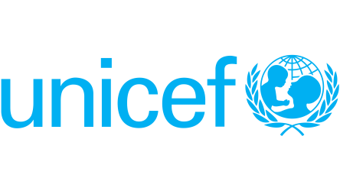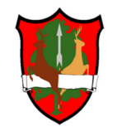

St Giles CE Primary School

Walsall Street

Willenhall

West Midlands

WV13 2ER

1st December 2022

Dear Deirdre,

Thank you very much for our virtual workshop today about how Water Aid helps people across the world. It has shown us how our Global Goal of Clean water and sanitation for all is trying to be achieved throughout the world.

It was fascinating to see how the three steps of clean water, good sanitation and good hygiene can be used to help so many people who would otherwise have to travel long distances to collect drinking filthy water that would make them ill.

It was interesting to hear how you use pumps and water harvesting to collect safe drinking water, how encouraging people to make composting toilets and how simple messages about hygiene can help save so many lives.

In our country, we are so used to being able to turn on the tap and get safe clean water that we do not really think about how it arrives and how our waste just disappears with the flush of the toilet.

We think that you do an amazing job and that we all need to think carefully about how we use water in this country, that we should not take it for granted and think about those who do not have instant clean water.

We also had a few questions that you may be able to answer.

How do you help so many different communities throughout the world?

Do governments help you deliver the aid?

What is the biggest achievement that Water Aid has helped with?

We would also like to know if there is anything that we as children can do to help you at Water Aid?

Thank you so much for showing us how your charity helps those in need around the world and keep up the good work.

Yours Sincerely

Class 4S